CLOUD COMPUTING

M.YASWANTH

192124222

EXP NO 1: CREATE A SIMPLE CLOUD SOFTWARE APPLICATION AND PROVIDE IT AS A SERVICE USING ANY CLOUD SERVICE PROVIDER TODEMONSTRATE SOFTWARE AS A SERVICE (SAAS)

OUTPUT:

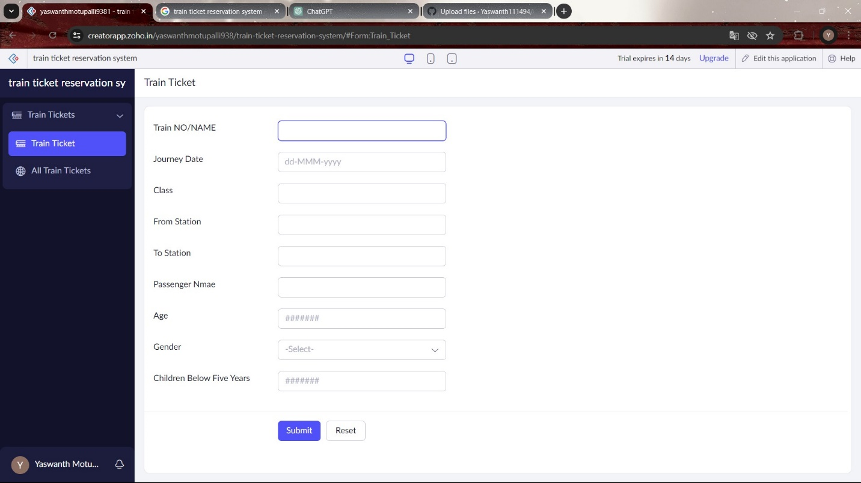

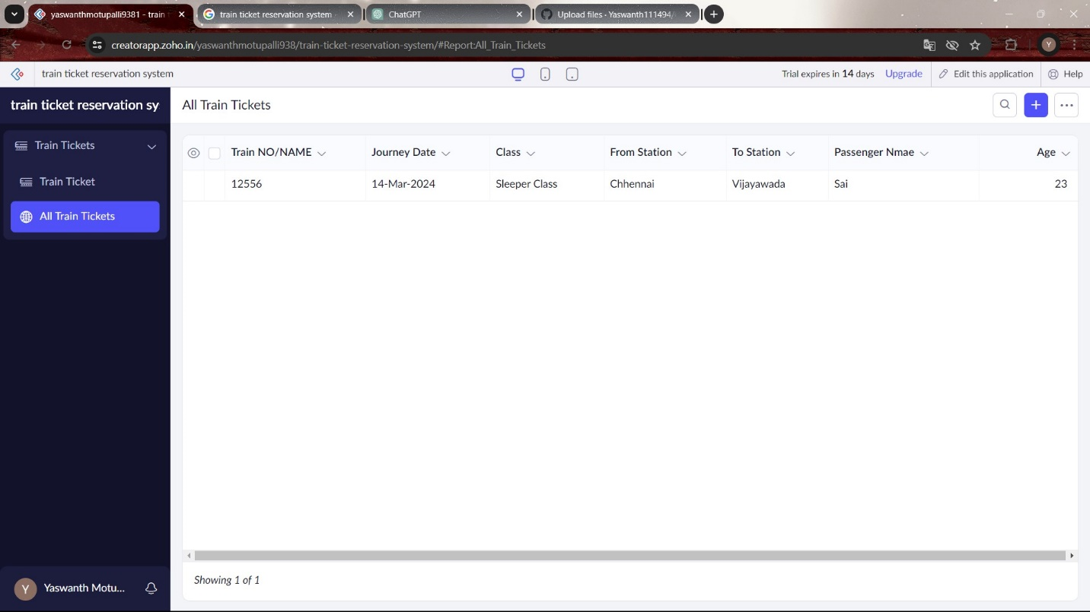

EXP NO 2: CREATE A SIMPLE CLOUD SOFTWARE APPLICATION FOR FLIGHT RESERVATION SYSTEM USING ANY CLOUD SERVICE PROVIDER TO DEMONSTRATE SAAS.

OUTPUT:

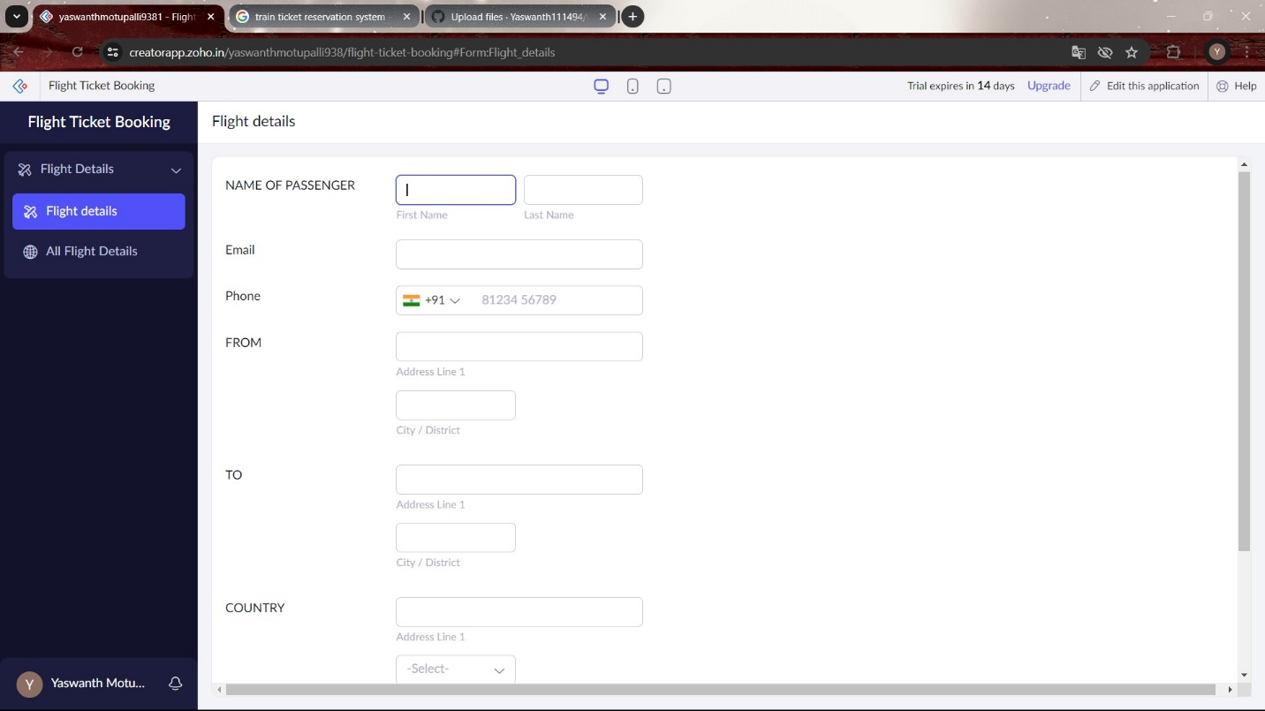

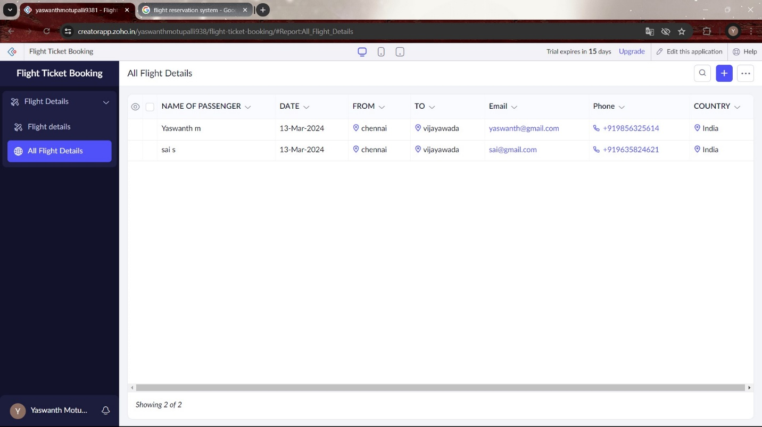

EXP NO 3: CREATE A SIMPLE CLOUD SOFTWARE APPLICATION FOR PROPERTY BUYING & RENTAL PROCESS (IN CHENNAI CITY) USING ANY CLOUD SERVICE PROVIDER TO DEMONSTRATE SAAS.

OUTPUT:

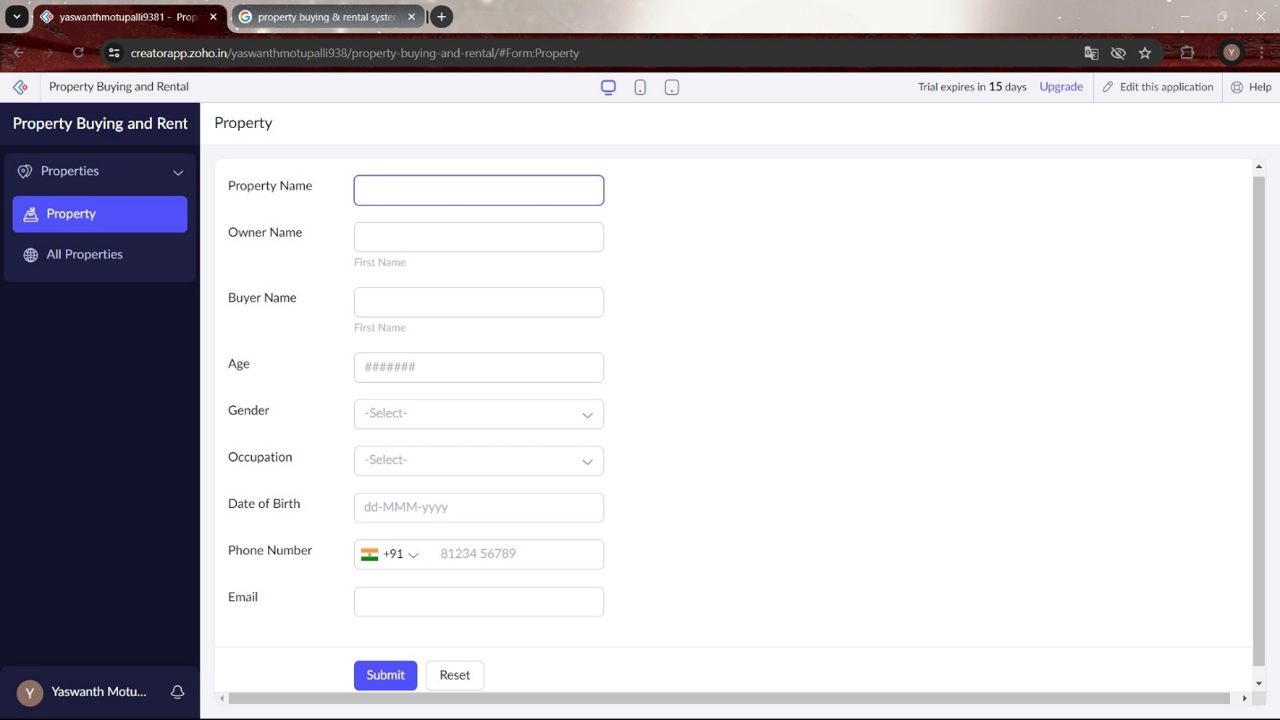

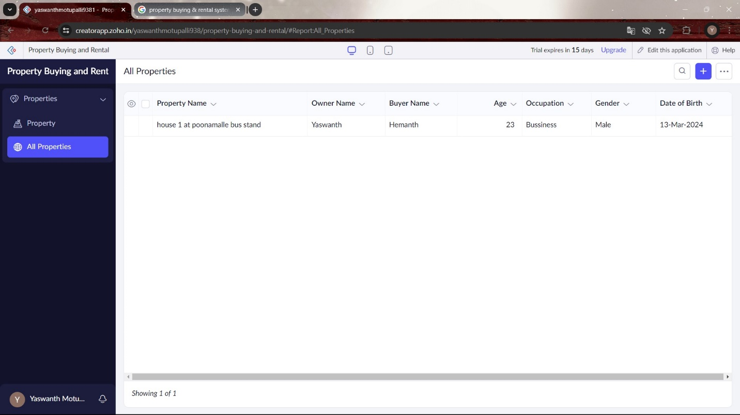

EXP NO 4: CREATE A SIMPLE CLOUD SOFTWARE APPLICATION FOR CAR BOOKING RESERVATION SYSTEM USING ANY CLOUD SERVICE PROVIDER TO DEMONSTRATE SAAS

OUTPUT:

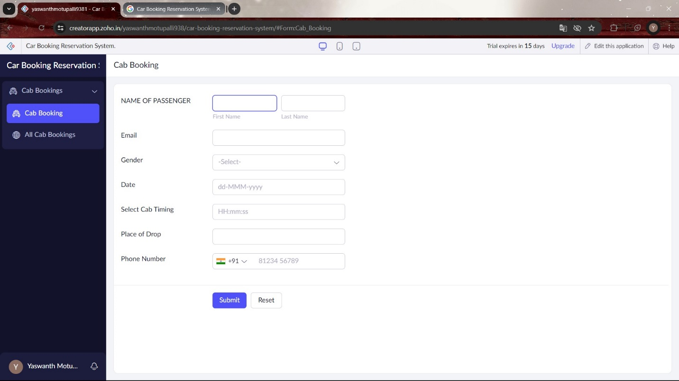

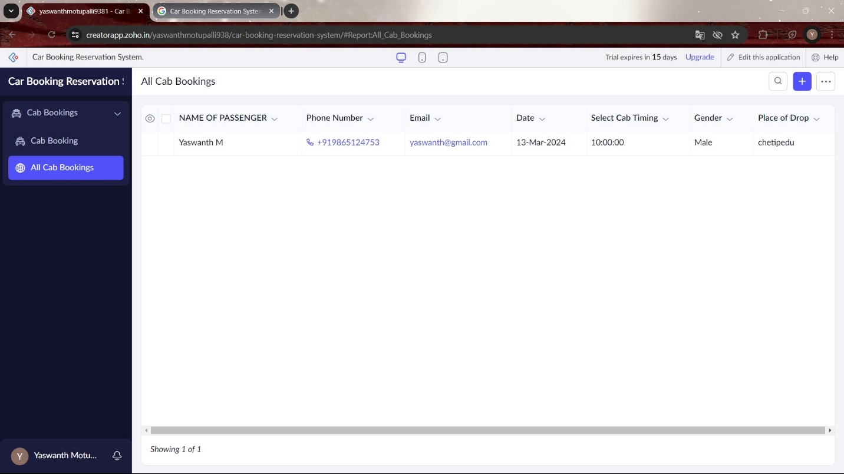

EXP NO 5: CREATE A SIMPLE CLOUD SOFTWARE APPLICATION FOR LIBRARY BOOK RESERVATION SYSTEM FOR SIMATS LIBRARY USING ANY CLOUD SERVICE PROVIDER TO DEMONSTRATE SAA

OUTPUT:

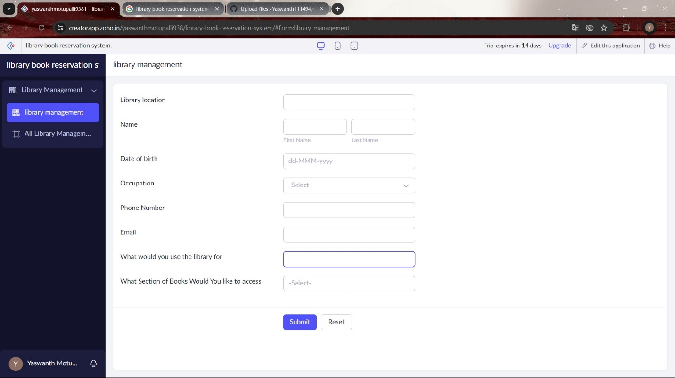

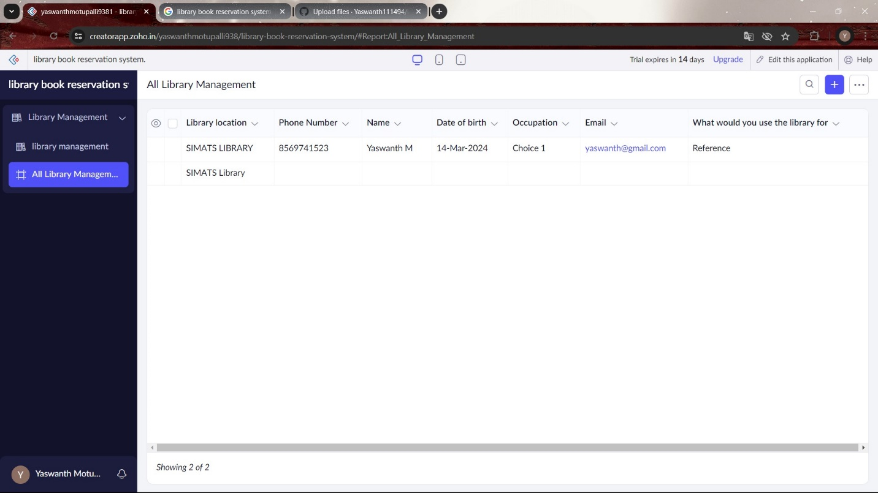

EXP NO 6: CREATE A SIMPLE CLOUD SOFTWARE APPLICATION FOR PRODUCT SELLING USING ANY CLOUD SERVICE PROVIDER TO DEMONSTRATE SAAS

OUTPUT:

